LabAssignment4
Angelina Podolako s1125886
Radboud University

In this document, you will collect the results of this assignment.:
Result of all 25 C# exercises 2
The URL of the uploaded game Monument and a screenshot of the Monument. 6
Two screenshots of the populated environment using at least 10 objects from a free asset collection of your choice in a reasonable arrangement. 6

By the end of this unit, you will be able to:
• Create a Game Manager object that controls game states
• Detect where the user has clicked their mouse in order to create a click-based program
• Use the Canvas to create UI elements like a Title, Buttons, or score display
• Lock elements and objects into place on the UI with Anchors
• Use variables and script communication to update elements in the UI
• Make UI elements appear and disappear with .SetActive
• Use script communication and Game states to implement working “Game Over” screen
• Restart the game using a UI button and Scene Management class
• Add listeners to detect when a UI Button has been clicked and trigger functionality
• Set difficulty of gameplay from title screen by passing parameters between scripts

2. Mixamo – importing characters into Unity
- Image of the character imported from Mixamo into Unity

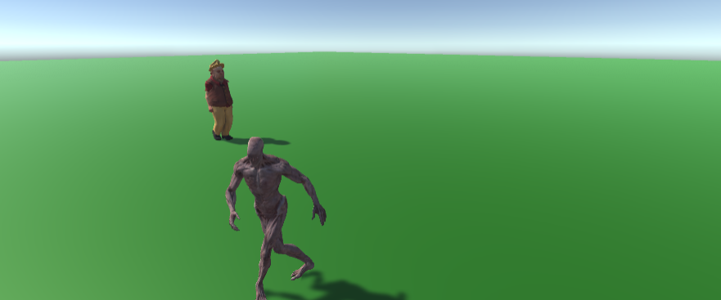
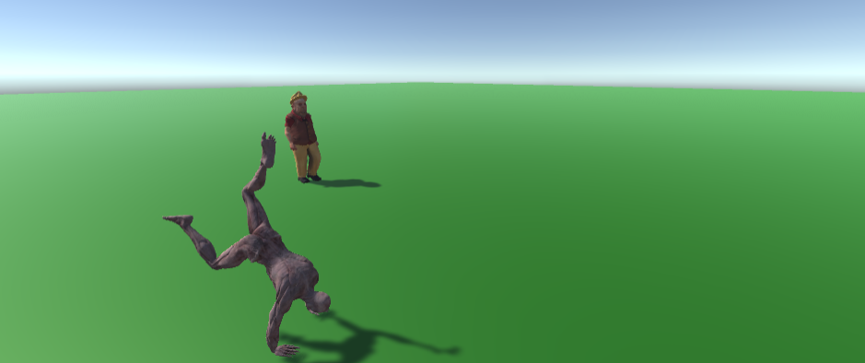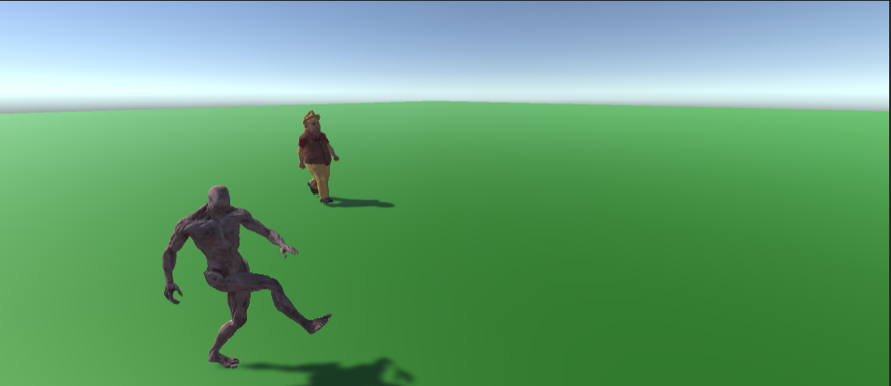

3. User interface
This tutorial can be found here: https://learn.unity.com/project/unit-5-user-interface.
You only have to do Lessons 5.1 through 5.4. Challenge 5, Lab 5 and Quiz 5 are not needed.
- URL of uploaded game in Unity Play of second tutorial
- C# scripts of Second tutorial (DifficultyButton.cs, GameManager.cs, Target.cs)

https://play.unity.com/mg/other/51-54-user-interface-padajutprodukti

DifficultyButton.cs
using System.Collections;
using System.Collections.Generic;
using UnityEngine;
using UnityEngine.UI;

public class DifficultyButton : MonoBehaviour
{
private Button button;
private GameManager gameManager;

public int difficulty;

// Start is called before the first frame update
void Start()
{
button = GetComponent<Button>();
button.onClick.AddListener(SetDifficulty);
gameManager = GameObject.Find("Game Manager").GetComponent<GameManager>();

button.onClick.AddListener(SetDifficulty);
}

// Update is called once per frame
void Update()
{

}

void SetDifficulty()
{
Debug.Log(button.gameObject.name + " was clicked");
gameManager.StartGame(difficulty);
}
}

GameManager.cs
using System.Collections;
using System.Collections.Generic;
using UnityEngine;
using TMPro;
using UnityEngine.SceneManagement;
using UnityEngine.UI;

public class GameManager : MonoBehaviour
{
public List<GameObject> targets;
public TextMeshProUGUI scoreText;
public TextMeshProUGUI gameOverText;
public Button restartButton;
public GameObject titleScreen;
public bool isGameActive;
private int score;
private float spawnRate = 1.0f;

// Start is called before the first frame update
void Start()
{

}

// Update is called once per frame
void Update()
{

}

IEnumerator SpawnTarget()
{
while(isGameActive)
{
yield return new WaitForSeconds(spawnRate);
int index = Random.Range(0, targets.Count);
Instantiate(targets[index]);
}
}

public void UpdateScore(int scoreToAdd)
{
score += scoreToAdd;
scoreText.text = "Score: " + score;
}

public void GameOver()
{
restartButton.gameObject.SetActive(true);
gameOverText.gameObject.SetActive(true);
isGameActive = false;

}
public void RestartGame()
{
SceneManager.LoadScene(SceneManager.GetActiveScene().name);
}

public void StartGame(int difficulty)
{
isGameActive = true;
score = 0;
spawnRate /= difficulty;

StartCoroutine(SpawnTarget());
UpdateScore(0);

titleScreen.gameObject.SetActive(false);
}
}

Target.cs
using System.Collections;
using System.Collections.Generic;
using UnityEngine;

public class Target : MonoBehaviour
{
private Rigidbody targetrb;
private GameManager gameManager;
private float minSpeed = 12;
private float maxSpeed = 16;
private float maxTorque = 10;
private float xRange = 4;
private float ySpawnPos = -6;

public ParticleSystem explosionParticle;
public int pointValue;

// Start is called before the first frame update
void Start()
{
targetrb = GetComponent<Rigidbody>();
gameManager = GameObject.Find("Game Manager").GetComponent<GameManager>();

targetrb.AddForce(RandomForce(), ForceMode.Impulse);
targetrb.AddTorque(RandomTorque(), RandomTorque(), RandomTorque(), ForceMode.Impulse);

transform.position = RandomSpawnPos();
}

// Update is called once per frame
void Update()
{

}

private void OnMouseDown()
{
if(gameManager.isGameActive)
{
Destroy(gameObject);
Instantiate(explosionParticle, transform.position, explosionParticle.transform.rotation);
gameManager.UpdateScore(pointValue);
}
}

private void OnTriggerEnter(Collider other)
{
Destroy(gameObject);

if(gameObject.CompareTag("Bad"))
{
gameManager.GameOver();
}
}

Vector3 RandomForce()
{
return Vector3.up * Random.Range(minSpeed, maxSpeed);
}

float RandomTorque()
{
return Random.Range(-maxTorque, maxTorque);
}

Vector3 RandomSpawnPos()
{
return new Vector3(Random.Range(-xRange, xRange), ySpawnPos);
}
}

4. Usability test
- Usability test questionnaire and results
- After that, you will write a small paragraph with 150 words about what you could perceive from the
participants and their answers to the questionnaire. You must also include the results of the questionnaires
showing from which game level is each questionnaire/result.

Both testers were pleased with the design of the game, the location of the buttons, and the selected colours.
From their answers, I realized that the easy level is already quite interesting and perhaps there is no need to make the game much more difficult. Due to the high difficulty, there is less interest in playing it.
There was an idea that a difficult level of the game is more convenient on phones than clicking with the mouse.
It may also be worth thinking about a smaller spawn of items, as well as so that they soar higher, so it will be a little easier to play, and interest in the game will grow.
Both testers reported that there was not enough music for such a game, which would calm the nerves on a difficult level.

Person1
Easy
 | not at all (0) | slightly (1) | moderately (2) | fairly (3) | extremely (4)
1 I felt skillful |  | x
2 I thought it was fun |  |  | x
3 I felt happy |  |  | x
4 I found it tiresome | x
5 I felt competent |  |  | x
6 I thought it was hard |  |  |  |  | x
7 It was aesthetically pleasing |  |  |  |  | x
8 I forgot everything around me |  | x
9 I felt good |  |  |  | x
10 I was good at it |  |  | x
11 I felt bored | x
12 I enjoyed it |  |  | x
13 I was fast at reaching the game's targets |  |  | x
14 I felt challenged |  |  |  |  | x
15 I was deeply concentrated in the game |  |  |  |  | x
16 I felt frustrated | x
Score | 0 | 2 | 12 | 3 | 16
Total score | 31

Hard
 | not at all (0) | slightly (1) | moderately (2) | fairly (3) | extremely (4)
1 I felt skillful | x
2 I thought it was fun |  | x
3 I felt happy |  |  | x
4 I found it tiresome |  | x
5 I felt competent |  |  | x
6 I thought it was hard |  |  |  |  | x
7 It was aesthetically pleasing |  |  |  |  | x
8 I forgot everything around me |  |  |  |  | x
9 I felt good |  |  | x
10 I was good at it |  | x
11 I felt bored | x
12 I enjoyed it |  | x
13 I was fast at reaching the game's targets |  | x
14 I felt challenged |  |  |  |  | x
15 I was deeply concentrated in the game |  |  |  |  | x
16 I felt frustrated | x
Score | 0 | 5 | 6 | 0 | 20
Total score | 31

Person2
Easy
 | not at all (0) | slightly (1) | moderately (2) | fairly (3) | extremely (4)
1 I felt skillful |  |  | x
2 I thought it was fun |  |  |  | x
3 I felt happy |  |  |  |  | x
4 I found it tiresome | x
5 I felt competent |  |  | x
6 I thought it was hard |  |  |  | x
7 It was aesthetically pleasing |  |  |  |  | x
8 I forgot everything around me |  |  |  |  | x
9 I felt good |  |  |  | x
10 I was good at it |  |  |  | x
11 I felt bored | x
12 I enjoyed it |  |  |  |  | x
13 I was fast at reaching the game's targets |  |  |  |  | x
14 I felt challenged |  |  |  | x
15 I was deeply concentrated in the game |  |  |  |  | x
16 I felt frustrated | x
Score | 0 | 0 | 14 | 15 | 24
Total score | 53

Hard

 | not at all (0) | slightly (1) | moderately (2) | fairly (3) | extremely (4)
1 I felt skillful |  | x
2 I thought it was fun |  | x
3 I felt happy |  |  |  |  | x
4 I found it tiresome |  | x
5 I felt competent | x
6 I thought it was hard |  |  |  |  | x
7 It was aesthetically pleasing |  |  |  |  | x
8 I forgot everything around me |  |  |  |  | x
9 I felt good |  |  | x
10 I was good at it |  | x
11 I felt bored | x
12 I enjoyed it |  |  | x
13 I was fast at reaching the game's targets |  |  | x
14 I felt challenged |  |  |  |  | x
15 I was deeply concentrated in the game |  |  |  |  | x
16 I felt frustrated | x
Score | 0 | 4 | 6 | 0 | 24
Total score | 34

